**Non-Linearity of Avalanche Photodiodes (APD) due to Multiplication factor and Complete output model of APD – A Report**

Hello Sir, as you instructed, I studied the non-linearity of avalanche photodiodes (APD) subjected to varying illumination. So, I went through the derivation of the multiplication factor of the APD and simulated the results using MATLAB to obtain the complete output model of the photodiode, which all I will cover in this report sir. In this setting we reverse bias the APD under a constant voltage and vary the input power given to it over a long range (I.e., from 10^-6 to 10^1 Watts).

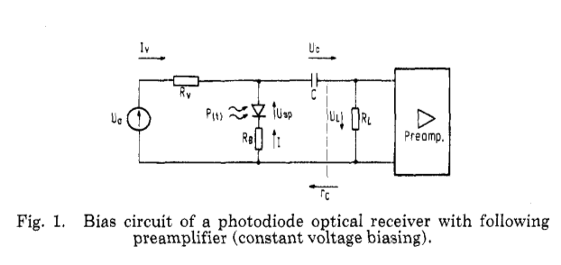

I will display the extremely important part of the derivation sir as the rest are not primary for us, the detailed derivation is in [1]

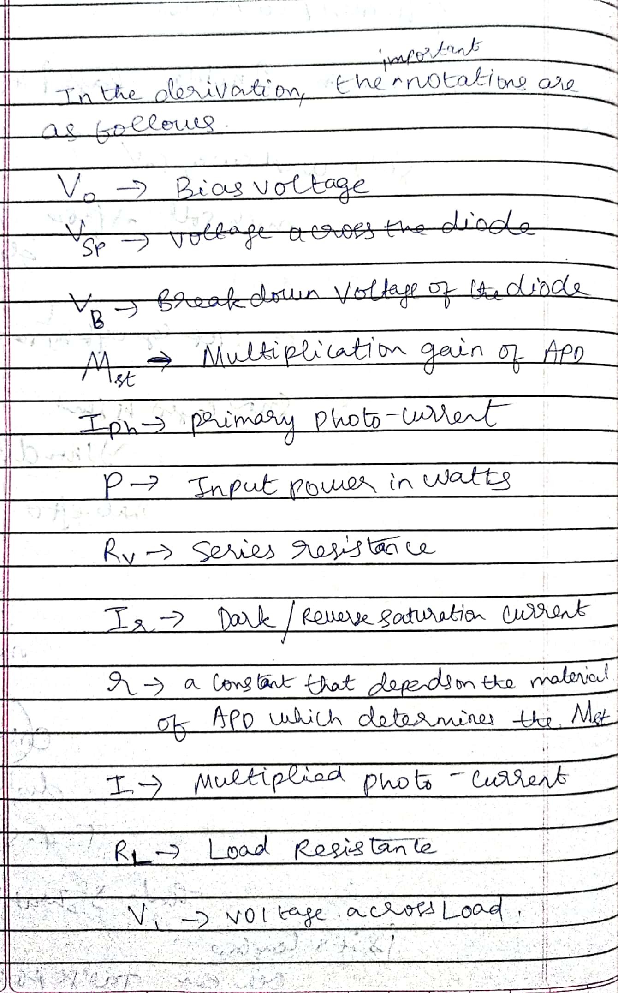

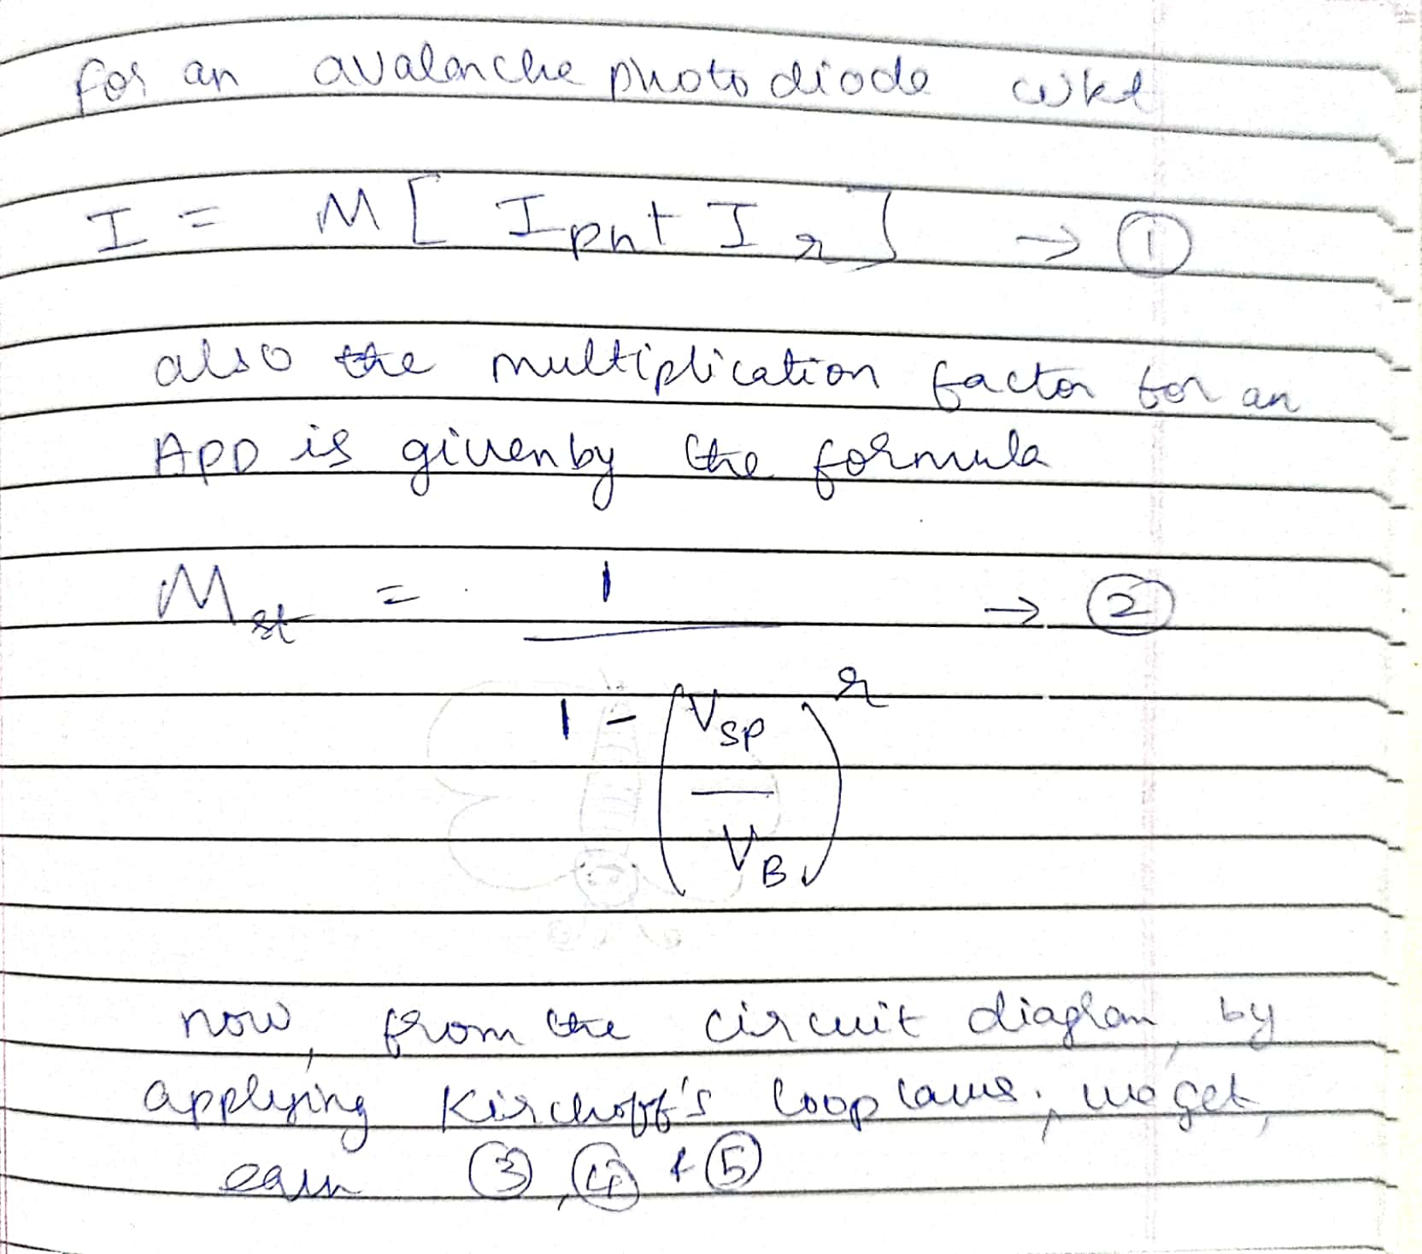

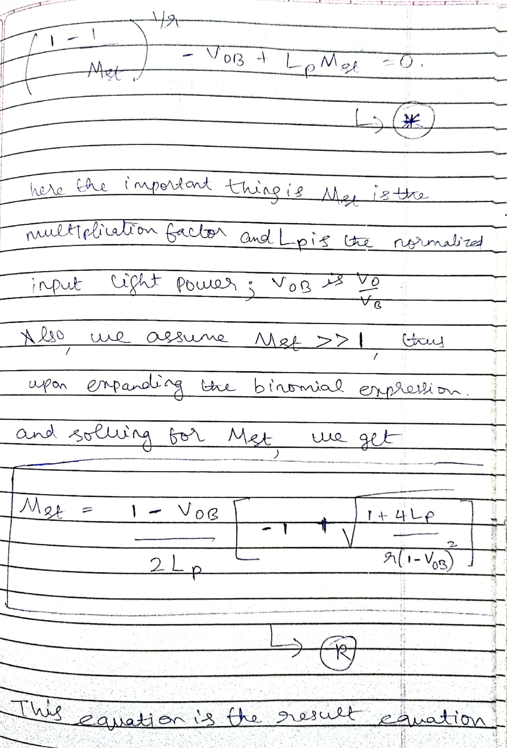

From equation **“R”** , I plotted two characteristics in MATLAB which is P v Mst and P v I. I set some parameters for the simulation as follows :

Rl (Load resistance) = 50 ohms, Vb (breakdown voltage of the diode) = 200 V, r=1.5, Initial value of Multiplication factor = 100 ( we assumed Mst >> 1 in our derivation by which we mean the starting or initial value).

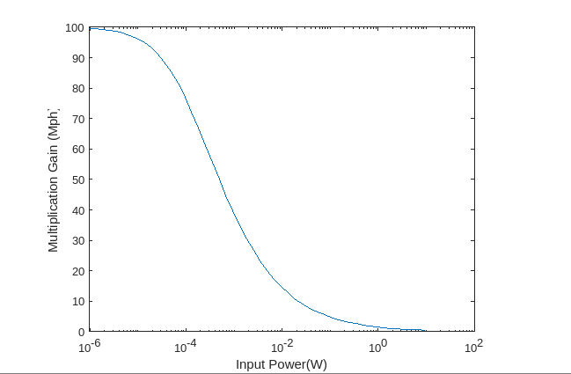

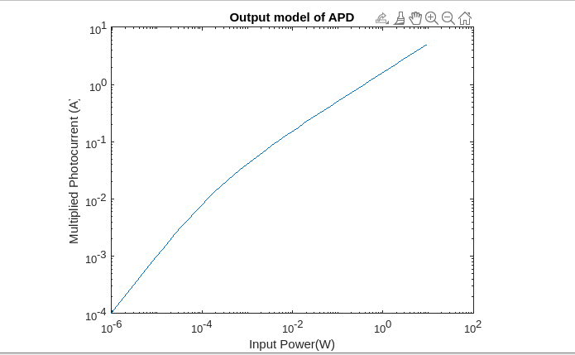

Now we can make an analytical observation from the plots side by side with making a theoretical observation from equation R.

If we observe equation R, for very low power levels Mst can be approximated as 1/r*(1-VoB), which means the multiplication factor is nearly a constant for very low light power levels.

From the plots, for very low light power levels (from 10^-6 to 10^-5) the P v M plot is nearly a constant, and the P v I plot has a linear trend, thus confirming the theoretical estimation that multiplication factor is nearly a constant for lower light power levels and the output multiplied photocurrent has a linear response to input power.

Now, for very high light power levels, Mst is proportional to 1/(Lp*sqrt(Lp)), which means the multiplication factor non-linearly reduces when Lp or P is increased.

We can clearly see the non-linear trend for both plots for P values greater than 10^-5, which confirms the theoretical observation.

And from this we obtained the complete model of the APD from the graph P v I, which contains both trends linearity as well as non-linearity.

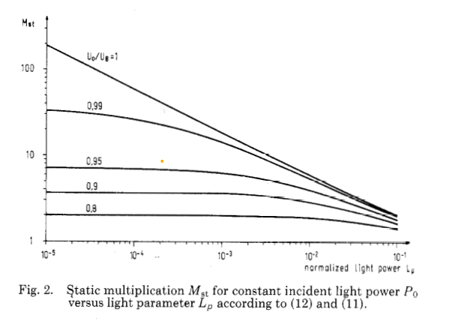

Now other important thing is note is that the ratio of bias voltage to breakdown voltage determines for what ‘length of power range’ does the multiplication factor remain nearly constant before starting to drop down, If the bias voltage is equal to breakdown voltage of the diode, then the multiplication factor starts to decrease as soon as we flash light into the APD, but for lower and lower ratios, the multiplication factor remains constant for greater range of input power values and thus the APD remains linear for the said range of input which is a desirable property of APD. The above is a plot depicting this phenomenon. Also, we can choose a particular APD with a particular initial multiplication gain according to our needs sir.

Thank You Sir

References:

1. <https://ieeexplore.ieee.org/document/1479198>
2. https://ieeexplore.ieee.org/document/8999582